**Earthquake prediction model using python**

**INTRODUCTION:**

An earthquake prediction model is a cutting-edge and essential tool in the field of seismology and disaster management. Earthquakes are natural phenomena that can cause significant damage and loss of life, making their prediction a matter of paramount importance. Such a model aims to harness the power of data analysis, advanced technologies, and scientific knowledge to forecast the occurrence, location, magnitude, and potential impact of seismic events**.**

**DATASET:**

The dataset can be taken from the following below link,

**Dataset link:**[**https://www.kaggle.com/datasets/usgs/earthquake-database**](https://www.kaggle.com/datasets/usgs/earthquake-database)

The above dataset is being used for the earthquake prediction. This dataset is the data of past time. It include the latitude, longitude , time, date, magnitude, etc..

**DATA COLLECTION AND PREPROCESSING:**

Data collection for earthquake prediction involves gathering various types of data related to seismic activity, geological features, and environmental conditions. The goal is to acquire comprehensive and high-quality data to feed into earthquake prediction models**.**

Data preprocessing is a critical step in earthquake prediction as it involves cleaning, transforming, and preparing the raw data for analysis and model training. This ensures that the data used for prediction is of high quality and can effectively reveal patterns and insights**.**

**PROGRAM:**

import pandas as pd

import numpy as np

from sklearn.ensemble import RandomForestRegressor

df = pd.read_csv('/content/database.csv.zip')

X = df[['Latitude', 'Longitude']]

y = df['Magnitude']

model = RandomForestRegressor()

model.fit(X, y)

predictions = model.predict(X)

print(model.score(X, y))

import matplotlib.pyplot as plt

plt.scatter(y, predictions)

plt.xlabel('Actual magnitude')

plt.ylabel('Predicted magnitude')

plt.show()

**OUTPUT:**

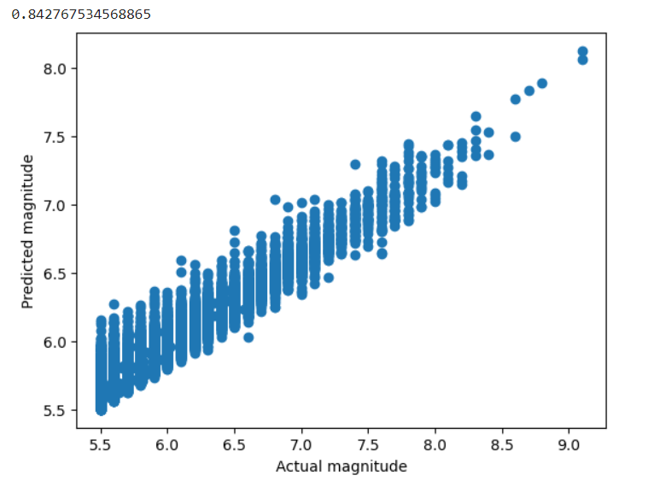

import requests

def get_recent_earthquakes():

    url = "https://earthquake.usgs.gov/earthquakes/feed/v1.0/summary/all_hour.geojson"

    response = requests.get(url)

    data = response.json()

    return data

def display_earthquake_data(earthquake_data):

    for feature in earthquake_data['features']:

        magnitude = feature['properties']['mag']

        place = feature['properties']['place']

        time = feature['properties']['time']

        print(f"Magnitude: {magnitude}, Location: {place}, Time: {time}")

if __name__ == "__main__":

    earthquake_data = get_recent_earthquakes()

    if earthquake_data:

        print("Recent Earthquakes:")

        display_earthquake_data(earthquake_data)

    else:

        print("Failed to retrieve earthquake data.")

**OUTPUT:**

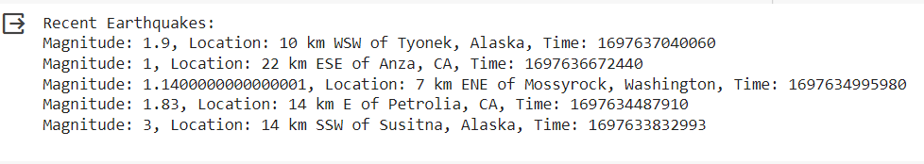

train = pd.read_csv('/content/database.csv.zip', nrows=6000000, dtype={'acoustic_data' : np.int16, 'time_to_failure':np.float64})

train.head(10)

**OUTPUT:**

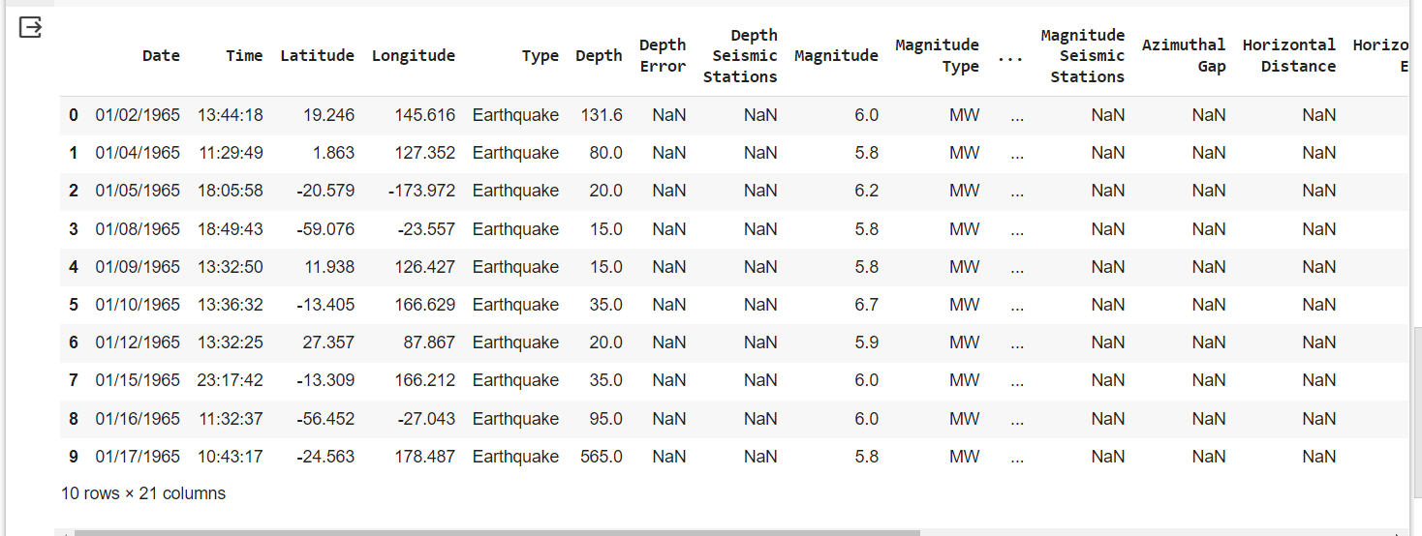

**CONCLUSION:**

In conclusion, earthquake prediction is a field of paramount importance, marked by its complexity and the potential to save lives and mitigate damage. The development of earthquake prediction models represents a significant stride forward in our understanding of seismic activity and disaster preparedness. This advanced technology leverages a multifaceted approach, integrating data from seismic sensors, geological surveys, environmental observations, and historical earthquake records to provide insights into when, where, and with what intensity earthquakes might occur.